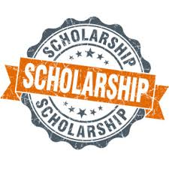
Need Money for College?

Apply for the Stokes & Kopitsky
$1,000 SCHOLARSHIP

Deadline April 30, 2022
@ 11:59PM
To apply, you must be a Junior or Senior attending a Cobb County High School.
Instructions are as follows:
1) Fill out application. This can be found online at stokesinjurylawyers.com/scholarship.
2) Write an essay on the topic “The Dangers of Drunk Driving.” Minimum 1,000 words, 2,000 words maximum.
3) Submit essay and application by emailing it to katie@stokeskopitsky.com or online at stokeskopitsky.com/scholarship.

Please contact Katie Schaff for questions by email at katie@stokeskopitsky.com or by phone 404-892-0011.

